Muhammad iftikhar
Nu – id p180054

Lab: 1
F1 = A’B’C+A’B’C+A’BC+ABC’+ABC+A’B’+BC’+AB
Truth Table:-
A | B | C | F1
0 | 0 | 0 | 1
0 | 0 | 1 | 1
0 | 1 | 0 | 1
0 | 1 | 1 | 1
1 | 0 | 0 | 0
1 | 0 | 1 | 0
1 | 1 | 0 | 1
1 | 1 | 1 | 1

Circuit diagram :
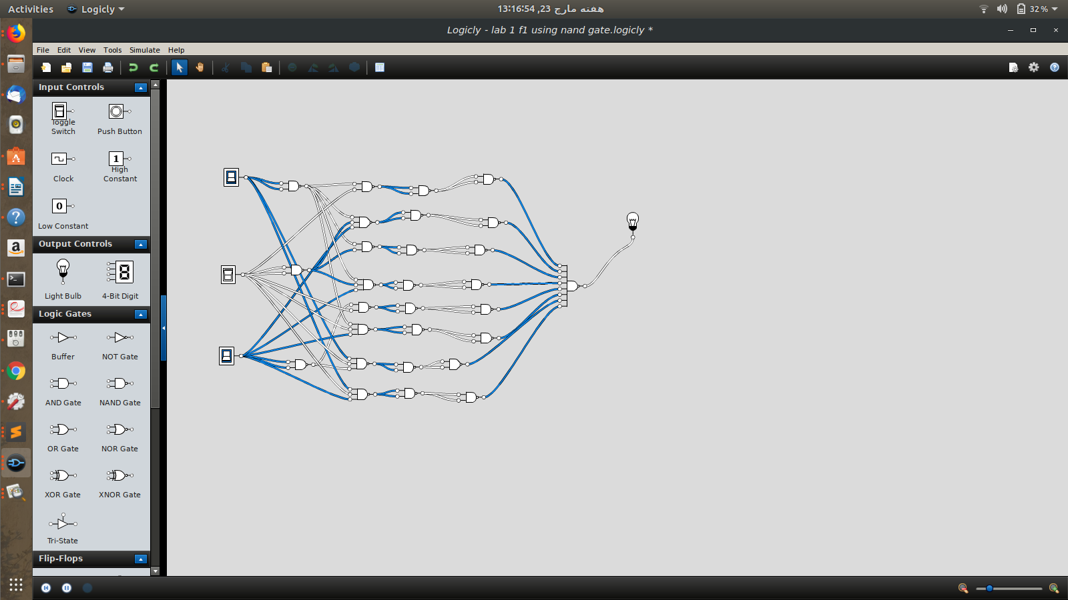

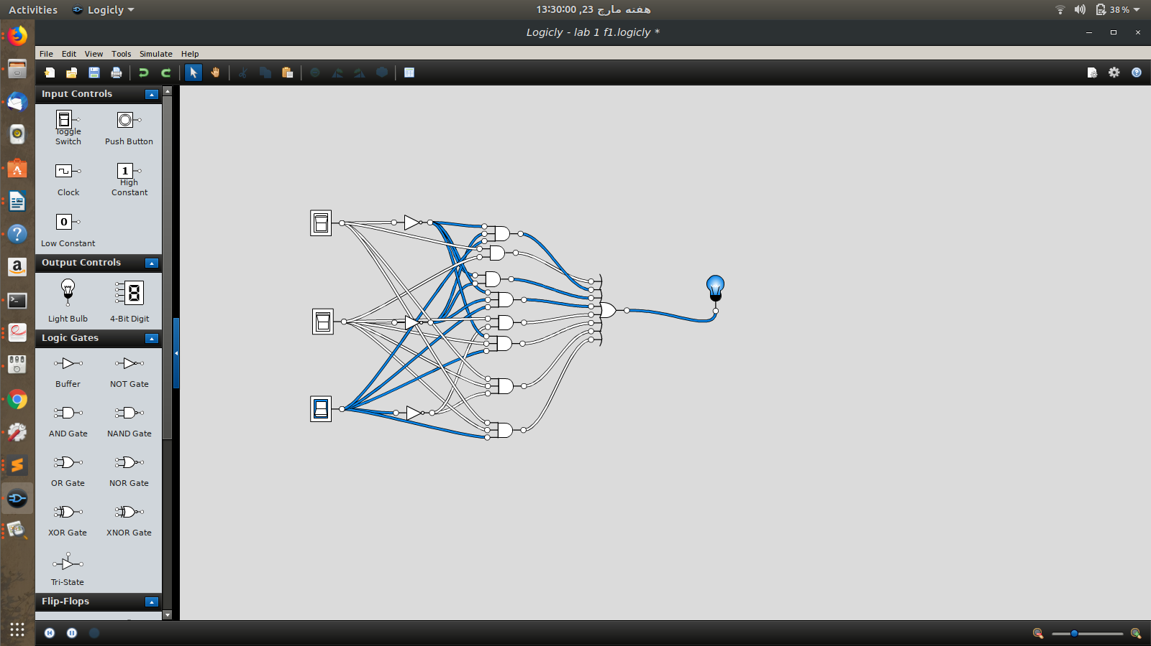
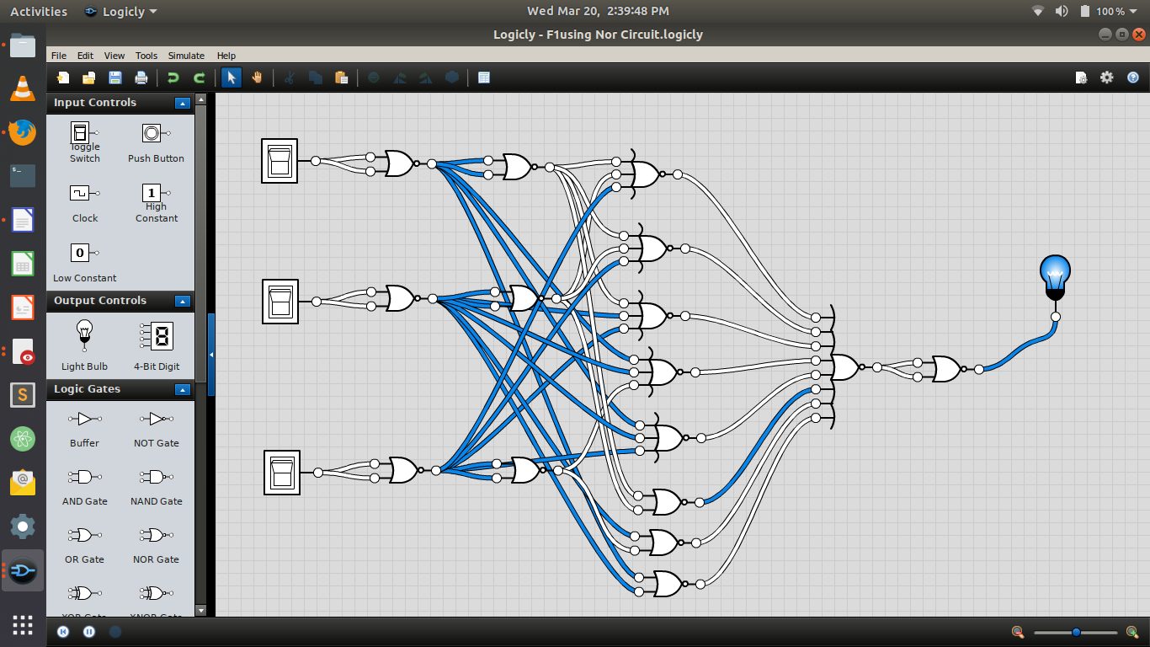

F2= A’B’C’D+AB’C’D+A’BC’D+ABC’D+A’BCD+ABCD
Truth Table;-
A | B | C | D | F2
0 | 0 | 0 | 0 | 0
0 | 0 | 0 | 1 | 1
0 | 0 | 1 | 0 | 0
0 | 0 | 1 | 1 | 0
0 | 1 | 0 | 0 | 0
0 | 1 | 0 | 1 | 1
0 | 1 | 1 | 0 | 0
0 | 1 | 1 | 1 | 1
1 | 0 | 0 | 0 | 0
1 | 0 | 0 | 1 | 1
1 | 0 | 1 | 0 | 0
1 | 0 | 1 | 1 | 0
1 | 1 | 0 | 0 | 0
1 | 1 | 0 | 1 | 1
1 | 1 | 1 | 0 | 0
1 | 1 | 1 | 1 | 1

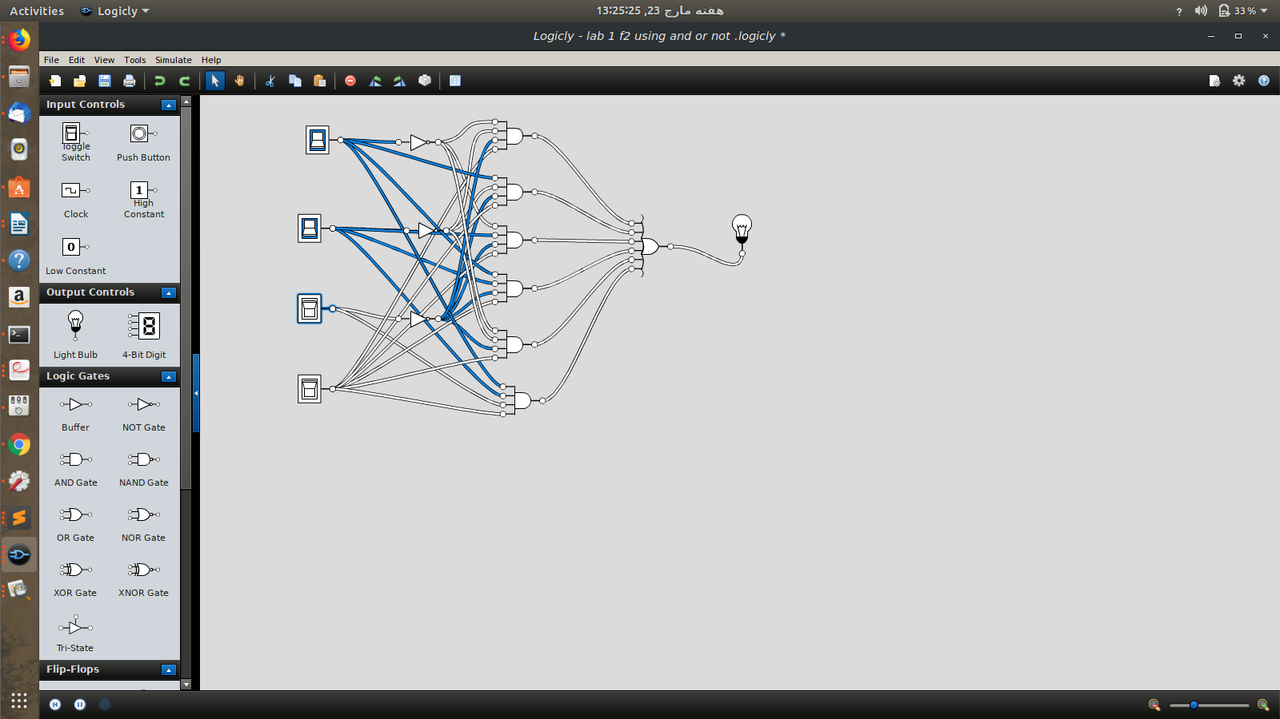

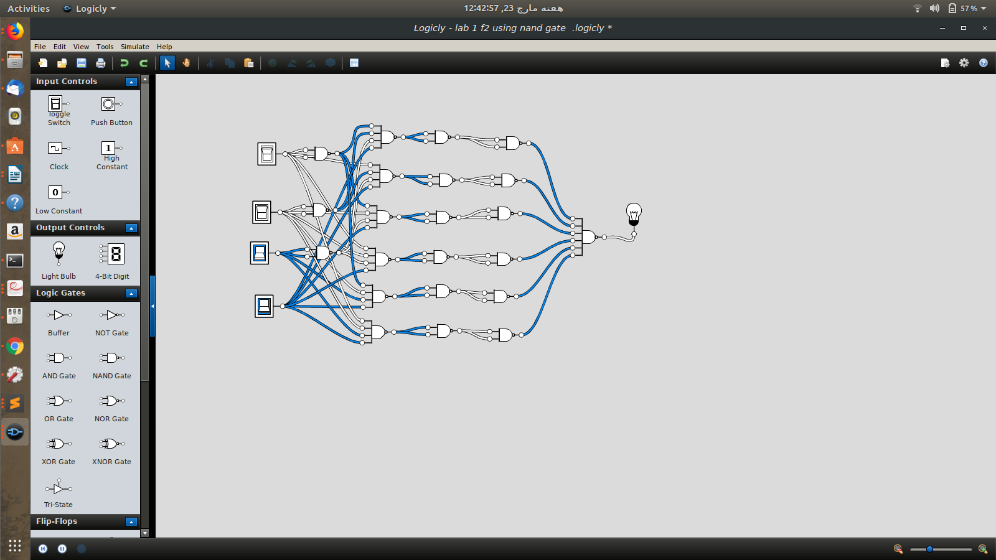

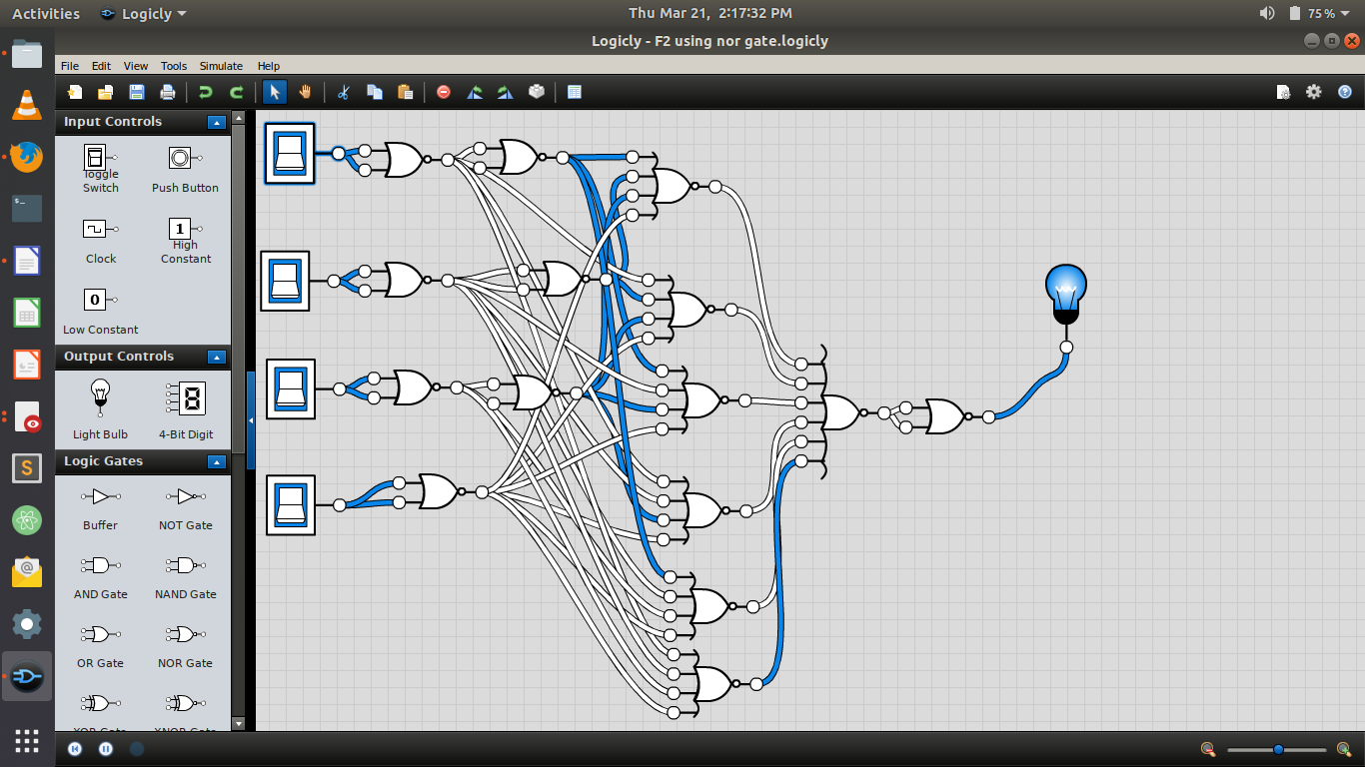

F3 = AB+A’BC’D+A’BCD+AB’C’D

Truth Table:-

A | B | C | D | F3
0 | 0 | 0 | 0 | 0
0 | 0 | 0 | 1 | 0
0 | 0 | 1 | 0 | 0
0 | 0 | 1 | 1 | 1
0 | 1 | 0 | 0 | 0
0 | 1 | 0 | 1 | 1
0 | 1 | 1 | 0 | 0
0 | 1 | 1 | 1 | 1
1 | 0 | 0 | 0 | 0
1 | 0 | 0 | 1 | 0
1 | 0 | 1 | 0 | 0
1 | 0 | 1 | 1 | 0
1 | 1 | 0 | 0 | 1
1 | 1 | 0 | 1 | 1
1 | 1 | 1 | 0 | 1
1 | 1 | 1 | 1 | 1

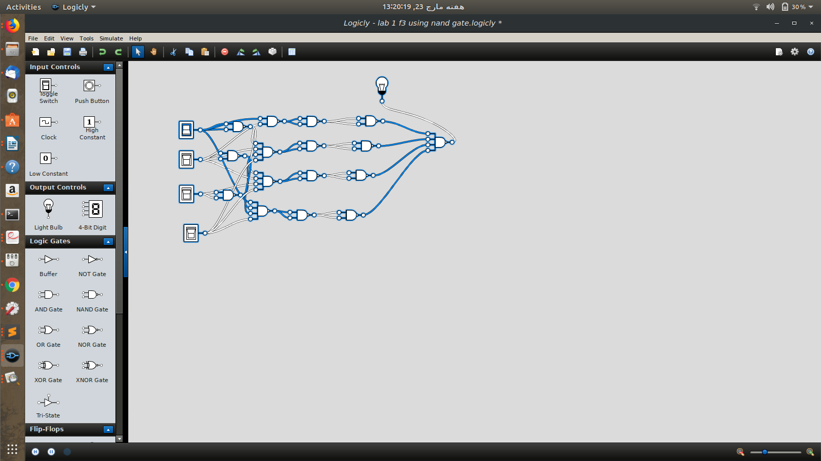

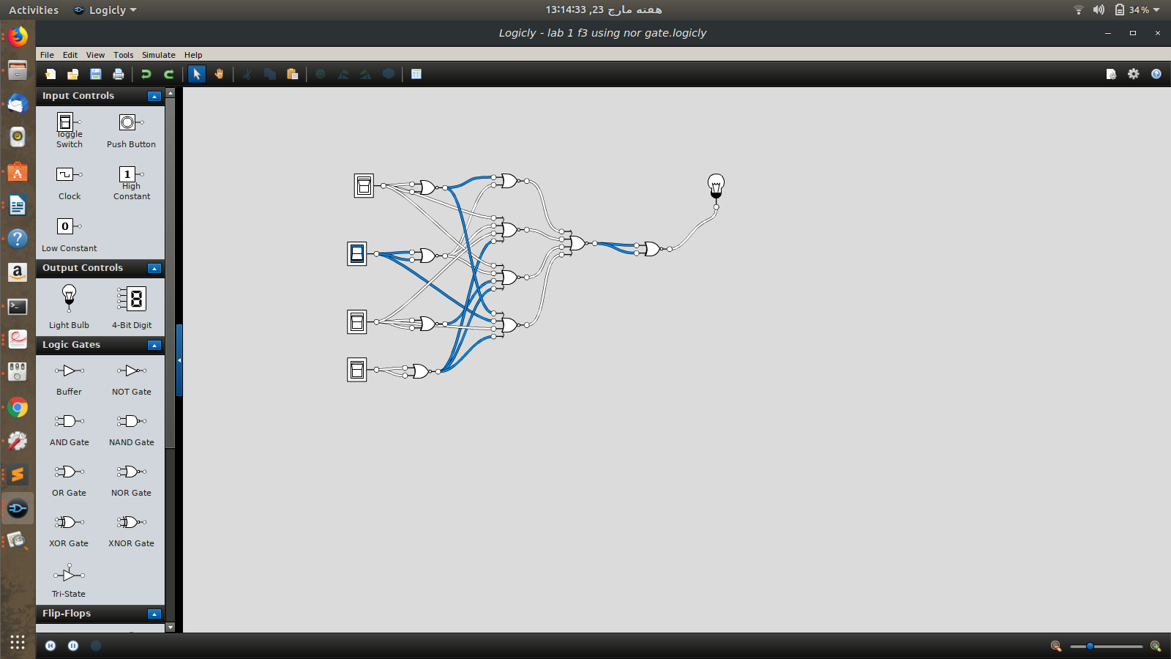

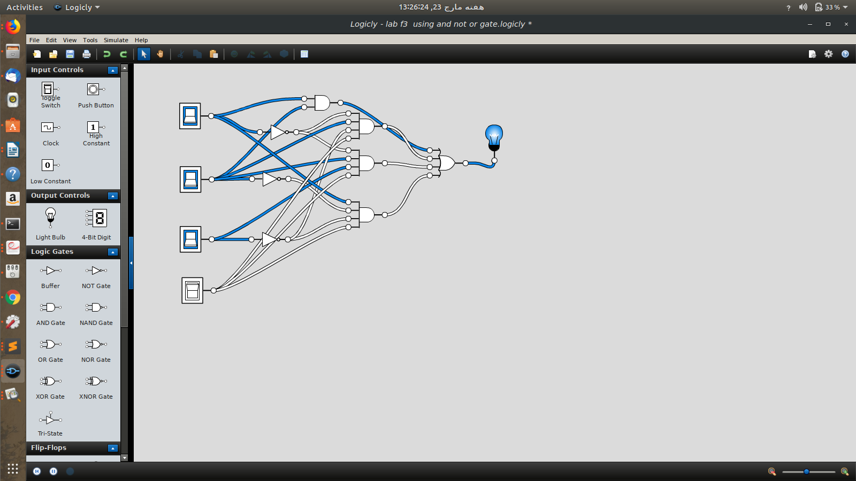

F4 = C + S where C = xy + xz + yz and S = C’ (x + y+ z) + xyz
Truth Table:-
x | y | z | F4
0 | 0 | 0 | 0
0 | 0 | 1 | 1
0 | 1 | 0 | 1
0 | 1 | 1 | 1
1 | 0 | 0 | 1
1 | 0 | 1 | 1
1 | 1 | 0 | 1
1 | 1 | 1 | 1

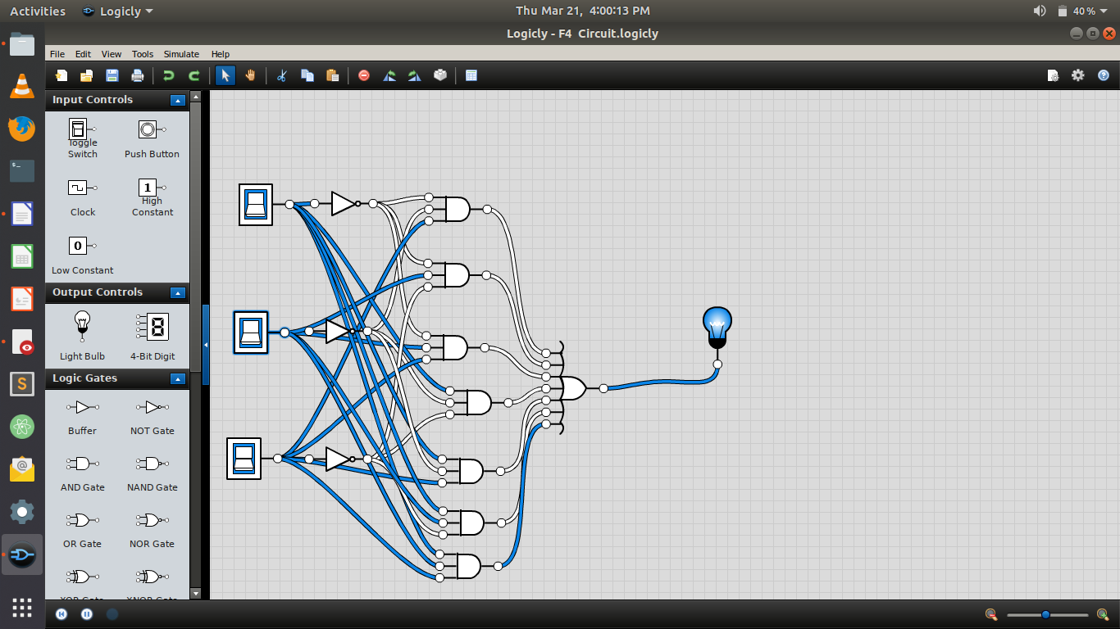

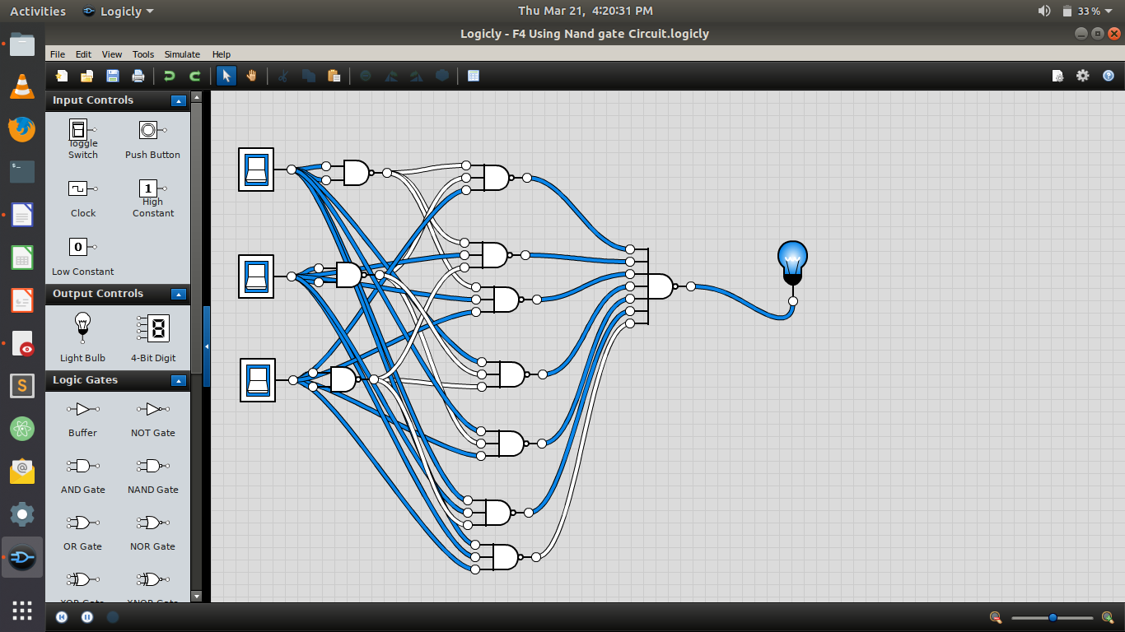

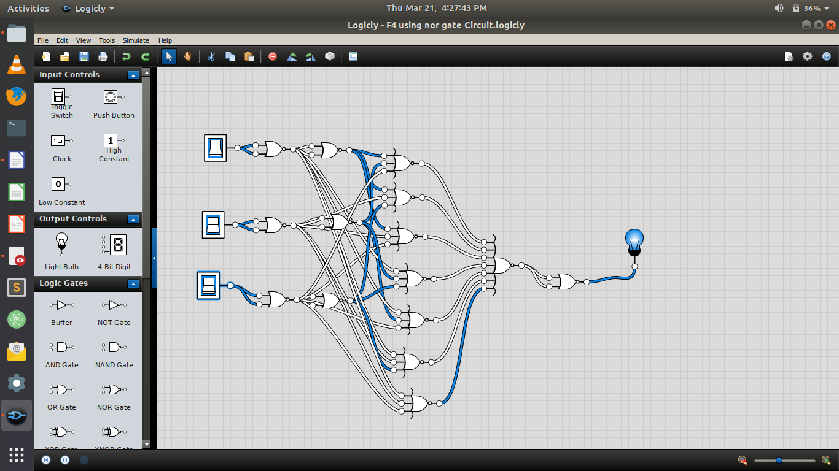

F5 = F1 + F2 (F4)

Truth Table:-

F1 | F2 | F4 | F2.F4 | F5=  F1+(F2.F4)
1 | 0 | 0 | 0 | 1
1 | 1 | 1 | 1 | 1
1 | 0 | 1 | 0 | 1
1 | 0 | 1 | 0 | 1
0 | 0 | 1 | 0 | 0
0 | 1 | 1 | 1 | 1
1 | 0 | 1 | 0 | 1
1 | 1 | 1 | 1 | 1
0 | 0 | 1 | 0 | 0
0 | 1 | 1 | 1 | 1
0 | 0 | 1 | 0 | 0
0 | 0 | 1 | 0 | 0
0 | 0 | 1 | 0 | 0
0 | 1 | 1 | 1 | 1
0 | 0 | 1 | 0 | 0
0 | 1 | 1 | 1 | 1

Circuit Diagram:-
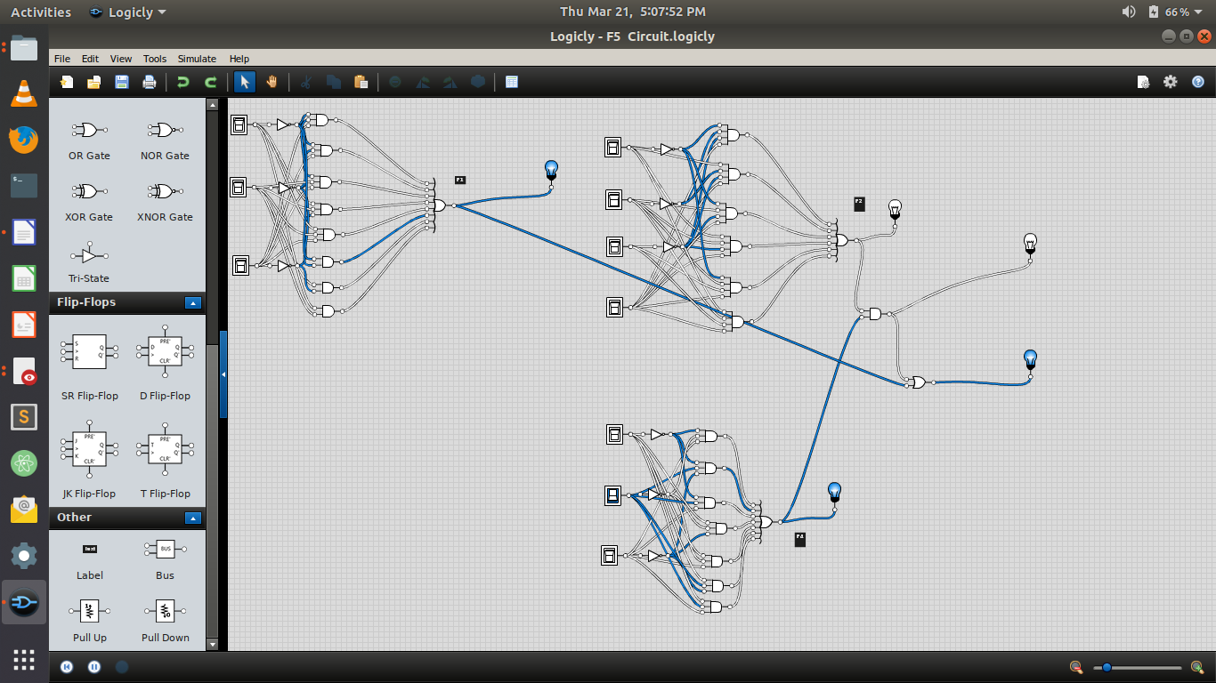
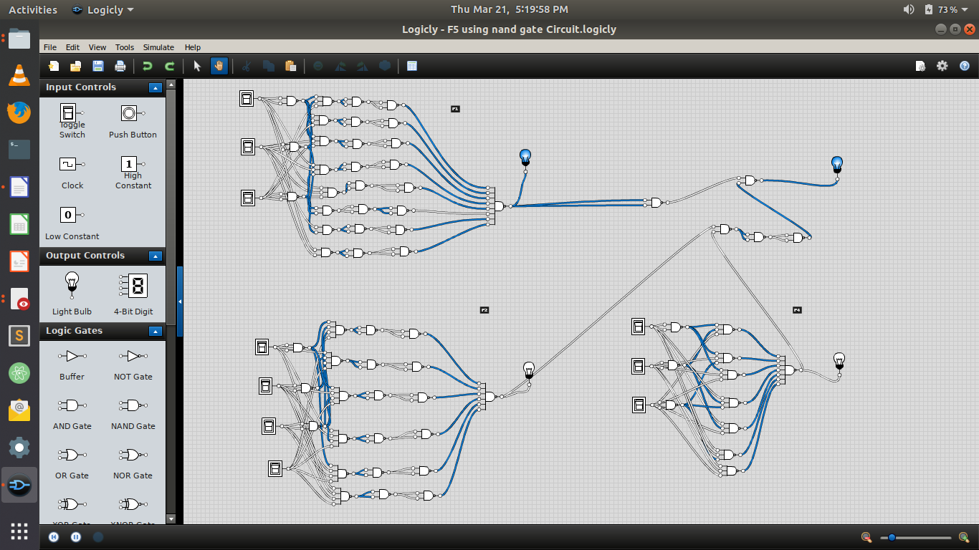
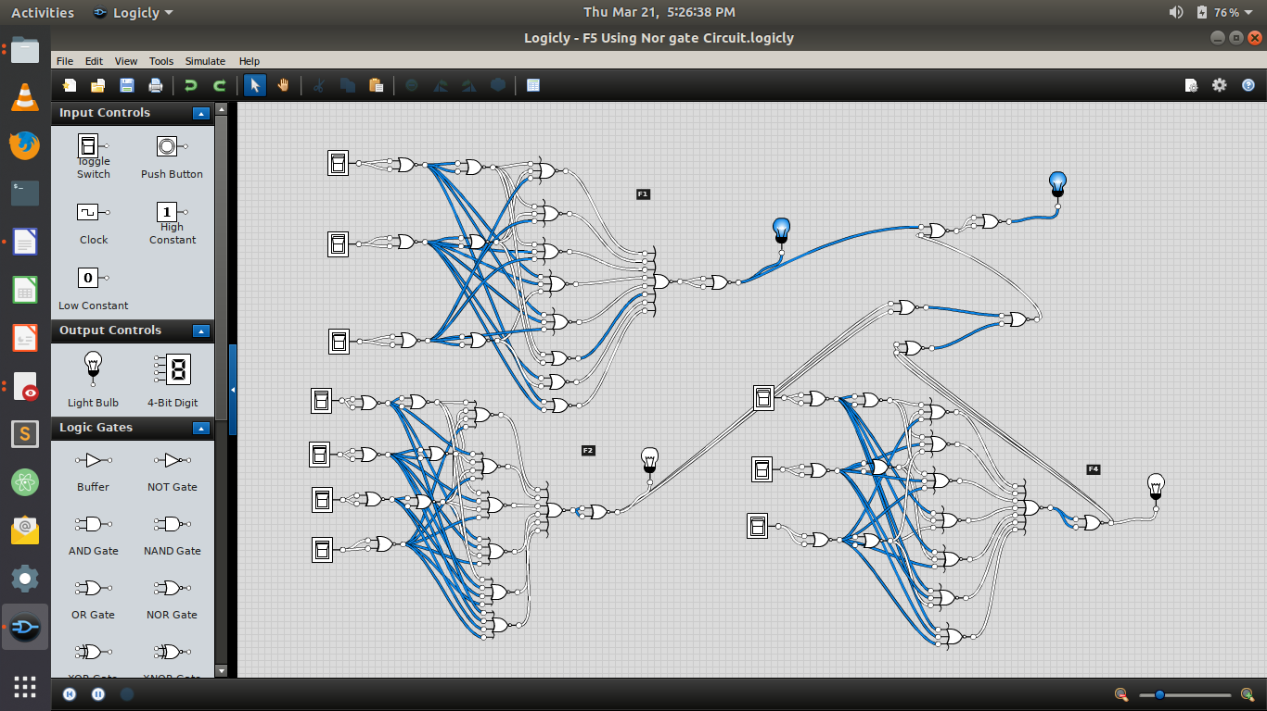

Lab 2-3;
f1
SOP:
original euation A’B’+AB’C+’BC+AB’+C+AB’+C’+AB
A’B’C+ABC+AB’C+A’B’C’+ABC’+AB’C’
A | B | C | output
0 | 0 | 0 | 1
0 | 0 | 1 | 1
0 | 1 | 0 | 0
0 | 1 | 1 | 0
1 | 0 | 0 | 1
1 | 0 | 1 | 1
1 | 1 | 0 | 1
1 | 1 | 1 | 1

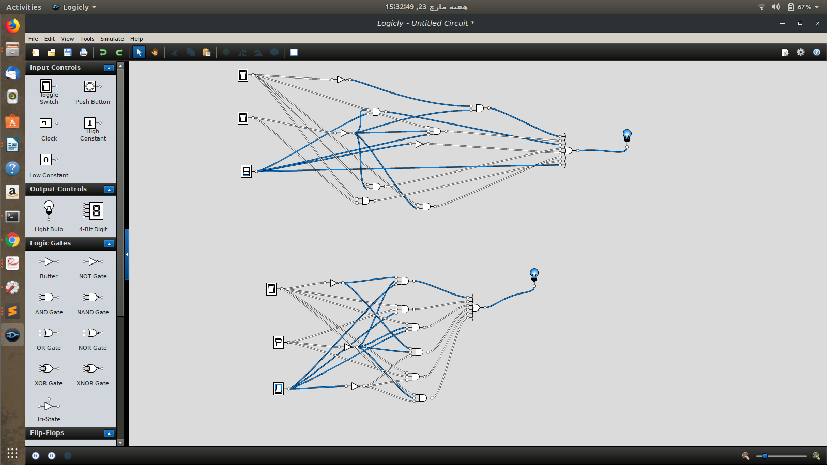

F2
SOP:
AB’C’D+ABC’D+ABC’D’+A’BC’D+ABCD+A’BCD+A’BCD’+A’BC’D’+AB’CD:
A | B | C | D | OUTPUT
0 | 0 | 0 | 0 | 0
0 | 0 | 0 | 1 | 1
0 | 0 | 1 | 0 | 0
0 | 0 | 1 | 1 | 0
0 | 1 | 0 | 0 | 1
0 | 1 | 0 | 1 | 1
0 | 1 | 1 | 0 | 1
0 | 1 | 1 | 1 | 1
1 | 0 | 0 | 0 | 0
1 | 0 | 0 | 1 | 1
1 | 0 | 1 | 0 | 0
1 | 0 | 1 | 1 | 1
1 | 1 | 0 | 0 | 1
1 | 1 | 0 | 1 | 1
1 | 1 | 1 | 0 | 0
1 | 1 | 1 | 1 | 1

Min Terms = A’B’C’D + A’BC’D’ + A’BC’D + A’BCD’ + A’BCD+ AB’C’ D+ AB’CD + ABC’D’ + ABC’D + ABCD

MaX Terms = (A+B+C+D) (A+B+C’+D)(A+B+C’+D’)
(A’+B+C+D)(A’+B+C’+D)(A’+B’+C’+D)

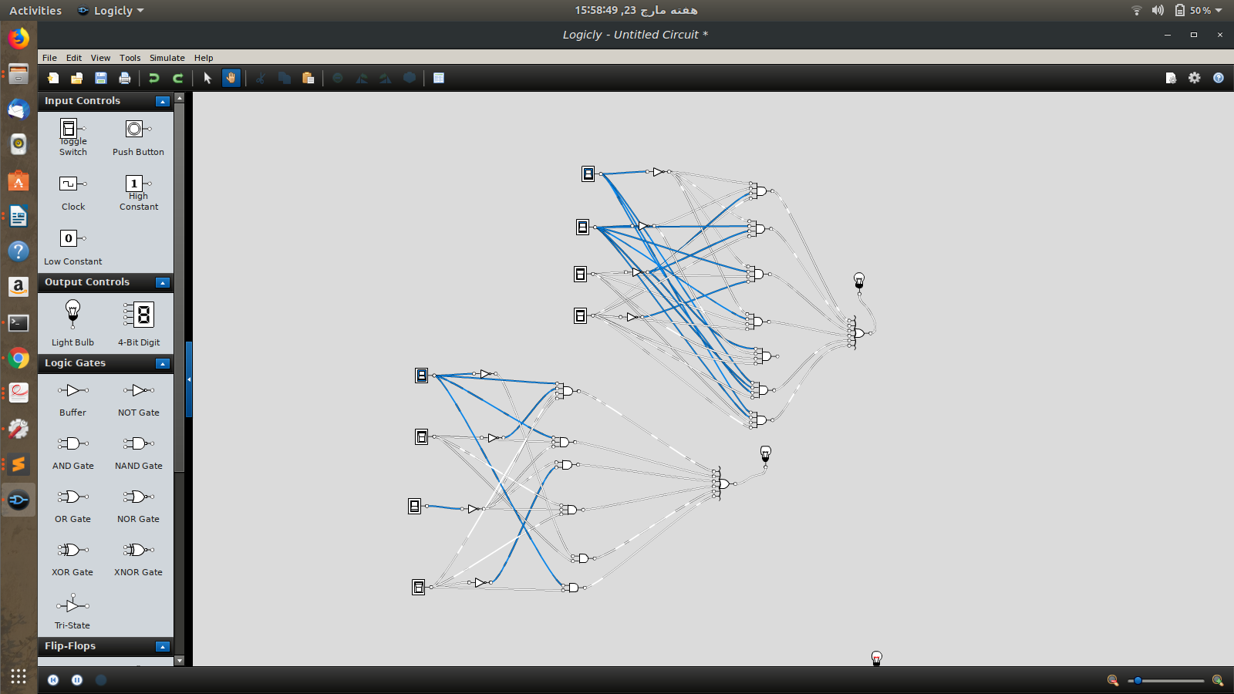
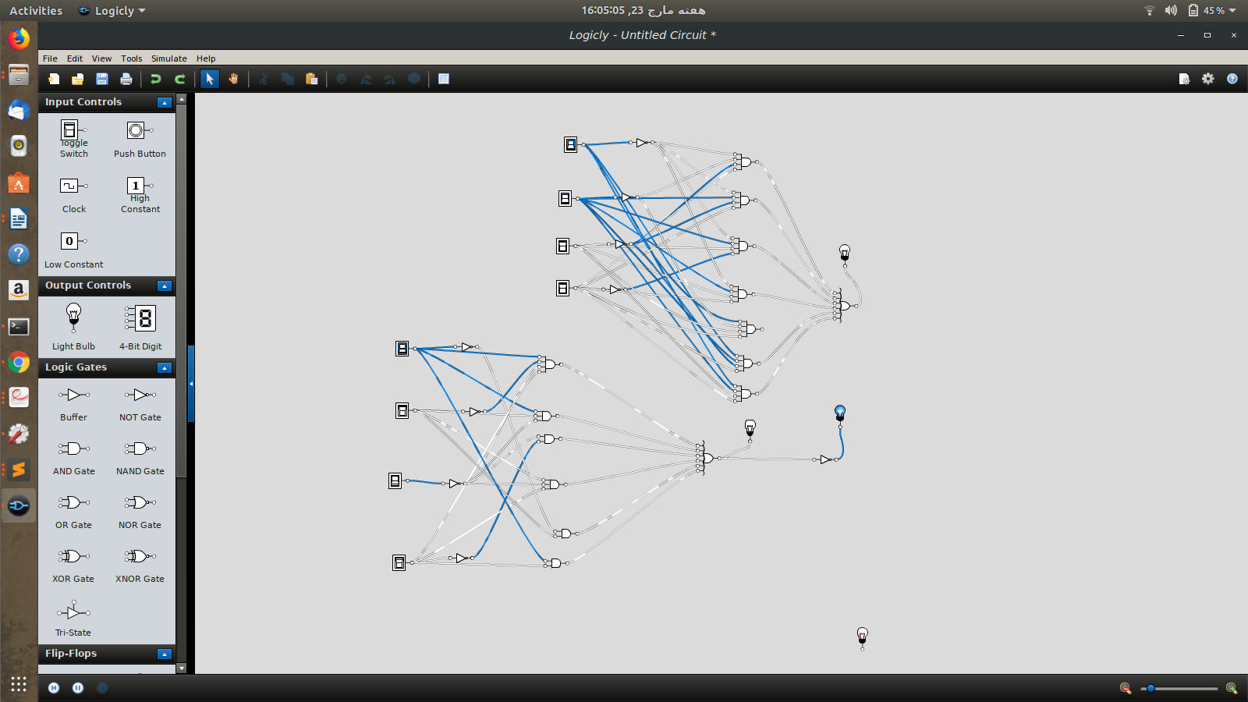
F3
POS;
ABC’D+ABC’D’+ABCD+ABCD’+A’B’CD+A’B’C’D+A’BC’D’+A’BC’D’+A’BCD’+A’BCD
A | B | C | D | OUTPUT
0 | 0 | 0 | 0 | 0
0 | 0 | 0 | 1 | 1
0 | 0 | 1 | 0 | 0
0 | 0 | 1 | 1 | 1
0 | 1 | 0 | 0 | 1
0 | 1 | 0 | 1 | 1
0 | 1 | 1 | 0 | 1
0 | 1 | 1 | 1 | 0
1 | 0 | 0 | 0 | 0
1 | 0 | 0 | 1 | 0
1 | 0 | 1 | 0 | 0
1 | 0 | 1 | 1 | 0
1 | 1 | 0 | 0 | 1
1 | 1 | 0 | 1 | 1
1 | 1 | 1 | 0 | 1
1 | 1 | 1 | 1 | 1
3:Circuit diagram

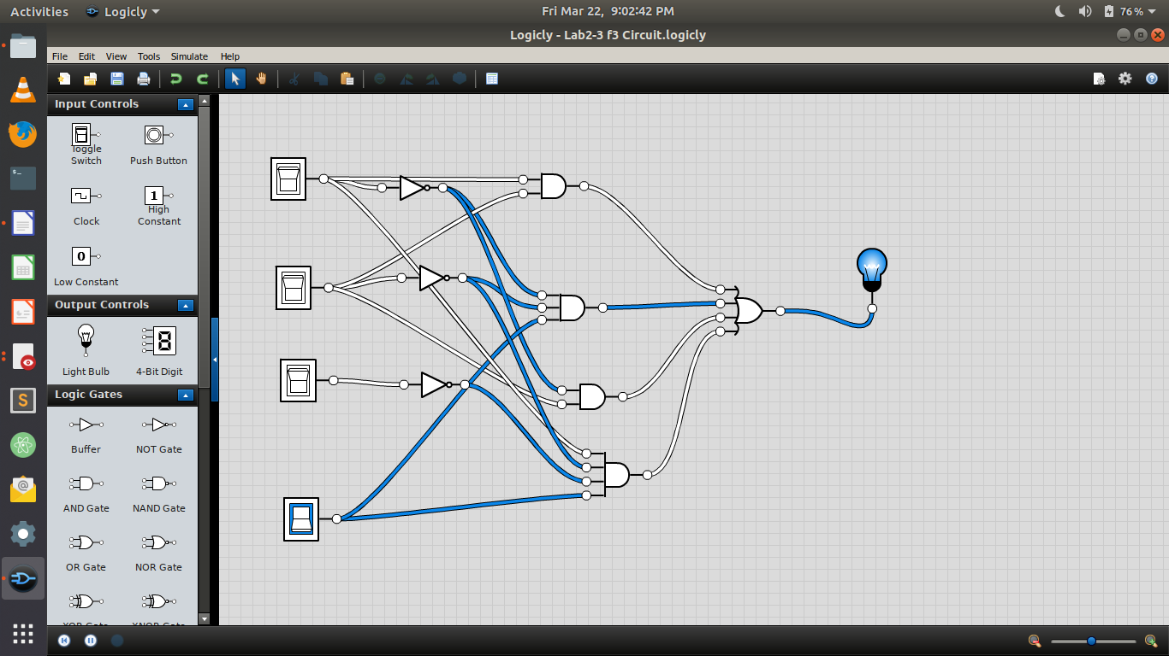
4:Inverse:
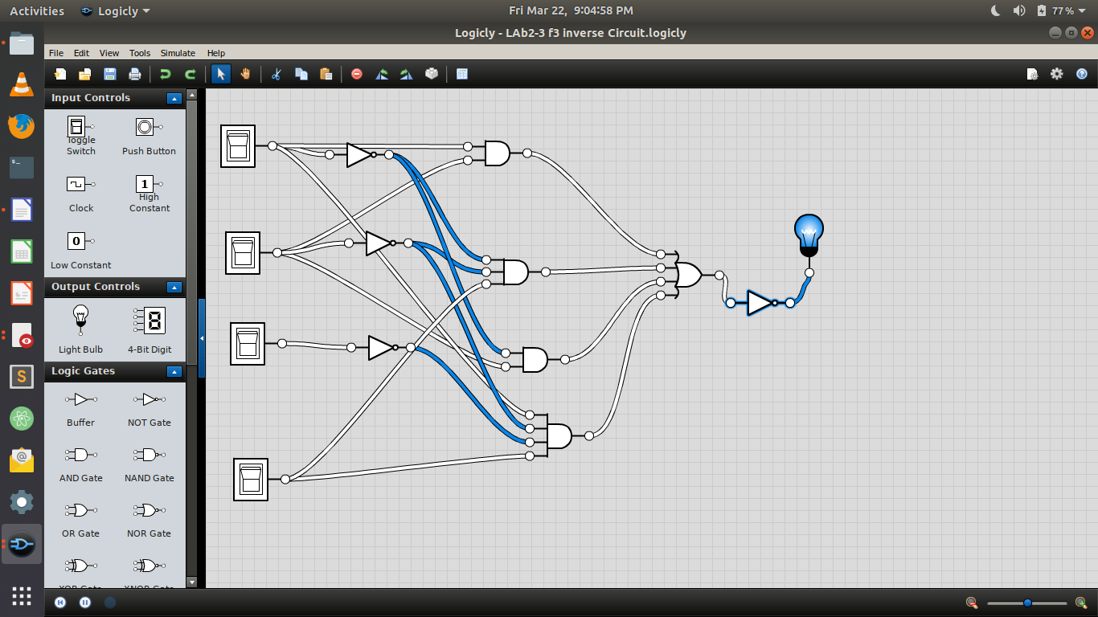

F4
POS :
XYZ’+XYZ+X’YZ+XY’Z+XY’Z’+X’YZ’
X | Y | Z | OUTPUT
0 | 0 | 0 | 0
0 | 0 | 1 | 0
0 | 1 | 0 | 1
0 | 1 | 1 | 1
1 | 0 | 0 | 1
1 | 0 | 1 | 1
1 | 1 | 0 | 1
1 | 1 | 1 | 1

Min Terms = x’yz’+x’yz+xy’z’+xy’z+xyz’+xyz

Max Terms = (x+y+z)(x+y+z’)

3:Circuit Diagram:

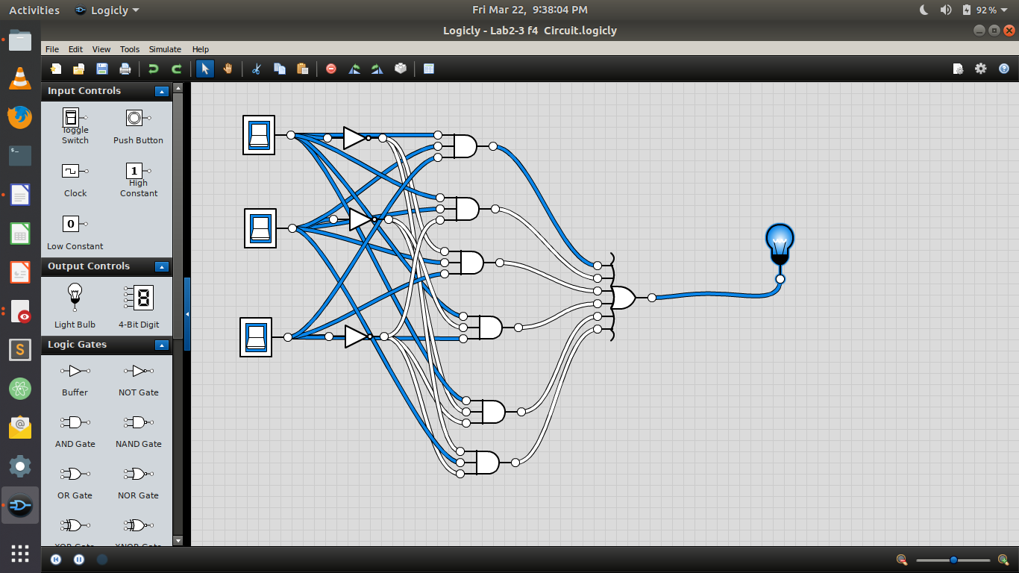
inverse

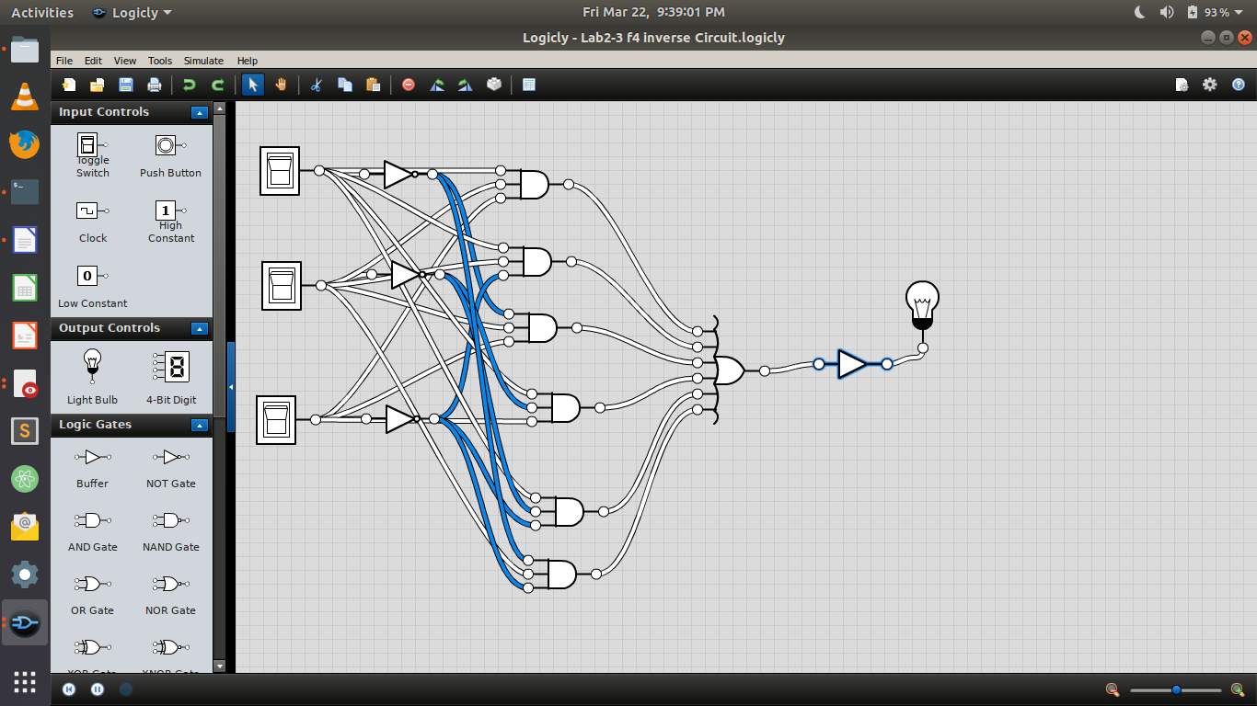

LAB 4-5;
f1:
EQUATION
A’B’C+A’B’C’+AB’C+A’BC+AB’C’+ABC’+ABC+A’BC’
A | B | C | OUTPUT
0 | 0 | 0 | 1
0 | 0 | 1 | 1
0 | 1 | 0 | 1
0 | 1 | 1 | 1
1 | 0 | 0 | 1
1 | 0 | 1 | 1
1 | 1 | 0 | 1
1 | 1 | 1 | 1

Simplified Equation by using K-map
1

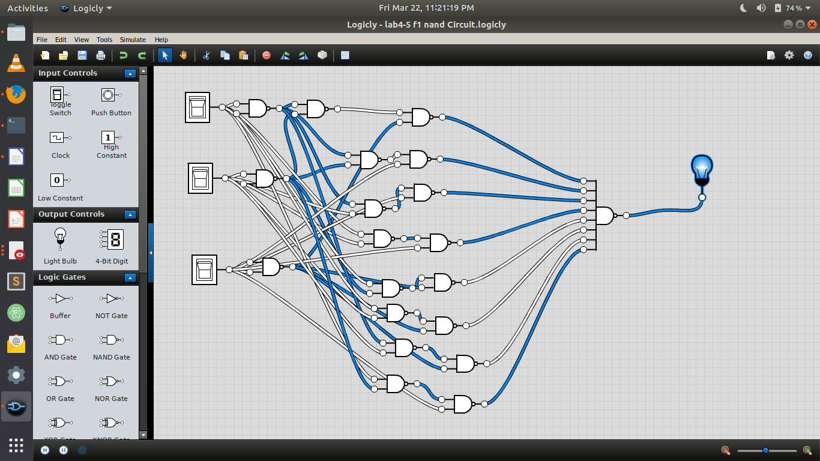

F2 = AB’C’D+AC’D+C’D+C’D+A’B+AD

A | B | C | D | OUTPUT
0 | 0 | 0 | 0 | 0
0 | 0 | 0 | 1 | 1
0 | 0 | 1 | 0 | 0
0 | 0 | 1 | 1 | 0
0 | 1 | 0 | 0 | 1
0 | 1 | 0 | 1 | 1
0 | 1 | 1 | 0 | 1
0 | 1 | 1 | 1 | 1
1 | 0 | 0 | 0 | 0
1 | 0 | 0 | 1 | 1
1 | 0 | 1 | 0 | 0
1 | 0 | 1 | 1 | 1
1 | 1 | 0 | 0 | 0
1 | 1 | 0 | 1 | 1
1 | 1 | 1 | 0 | 0
1 | 1 | 1 | 1 | 1

Simplified by using k_map C’D+A’B+AD+BD
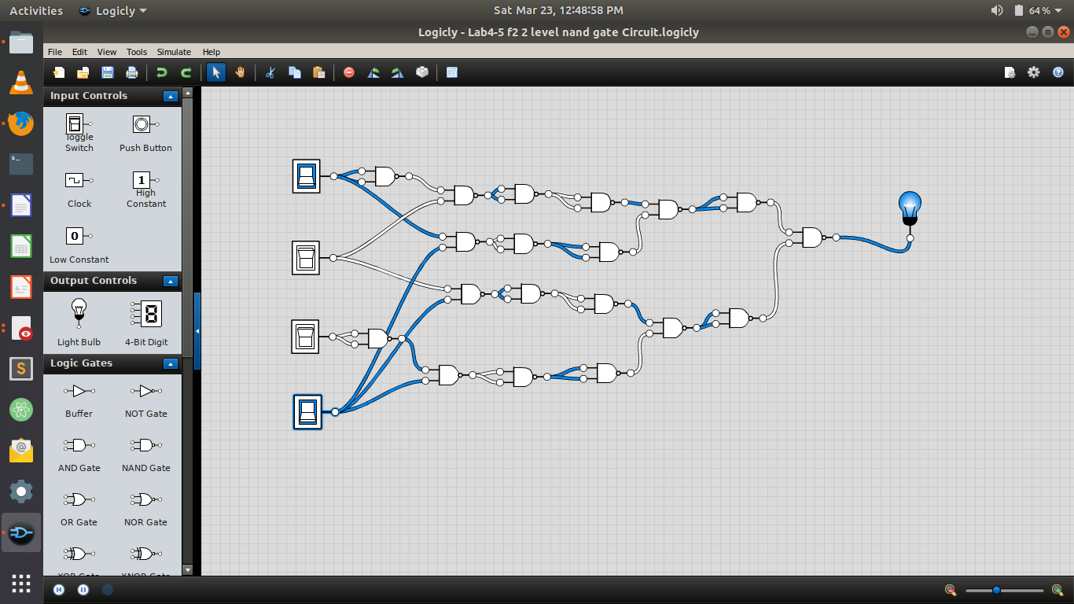

F3 = AB+A’C’D+A’BD+AB’C’
A | B | C | D | OUTPUT
0M0 | 0 | 0 | 0 | 0
0M1 | 0 | 0 | 1 | 1
0M2 | 0 | 1 | 0 | 0
0m3 | 0 | 1 | 1 | 0
0m4 | 1 | 0 | 0 | 0
0m5 | 1 | 0 | 1 | 1
0m6 | 1 | 1 | 0 | 0
0m7 | 1 | 1 | 1 | 1
1m8 | 0 | 0 | 0 | 1
1m9 | 0 | 0 | 1 | 1
1m10 | 0 | 1 | 0 | 0
1m11 | 0 | 1 | 1 | 0
1m12 | 1 | 0 | 0 | 1
1m13 | 1 | 0 | 1 | 1
1m14 | 1 | 1 | 0 | 1
1m15 | 1 | 1 | 1 | 1
Simplified by using k -map
(F3=C’D+AB+BD+AC’

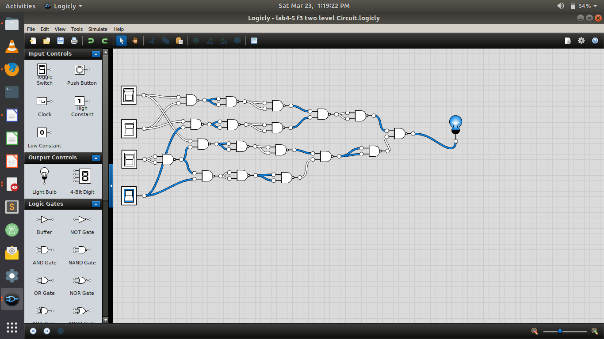
F4 = C + S where C = xy + yz and S = C’ (x + y) + xyz
simplified equatiion by using k map
A+B
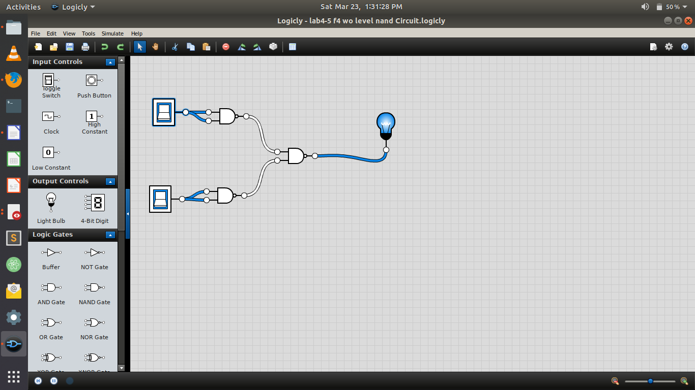

F5 = F3 + F1 (F4)
1:

F3 | F1 | F4 | F1.F4 | F5
0 | 1 | 0 | 0 | 0
1 | 1 | 0 | 0 | 1
0 | 1 | 1 | 1 | 1
0 | 1 | 1 | 1 | 1
0 | 1 | 1 | 1 | 1
1 | 1 | 1 | 1 | 1
0 | 1 | 1 | 1 | 1
1 | 1 | 1 | 1 | 1
1 | 1 | 1 | 1 | 1
1 | 1 | 1 | 1 | 1
0 | 1 | 1 | 1 | 1
0 | 1 | 1 | 1 | 1
1 | 1 | 1 | 1 | 1
1 | 1 | 1 | 1 | 1
1 | 1 | 1 | 1 | 1
1 | 1 | 1 | 1 | 1

Simplified by using k – map

F5=F1.F4+F1.F3


